Biblioteca Gráfica: QT Creator 4.5.1

Tutorial Executado

1. Instalação do Qt Creator Community

https://www.youtube.com/watch?v=eS7ank-qFjg

1. Programação Básica com GUI

<https://www.youtube.com/playlist?list=PLwmuiGfuGVTF601MkRsOAvIkQNINRFq5K>

1. QLabel

<https://www.youtube.com/watch?v=lIN86va9ZH4&list=PL2D1942A4688E9D63&t=0s&index=15>

1. QPushButton

<https://www.youtube.com/watch?v=dOovH6TvaY4&index=15&list=PL2D1942A4688E9D63>

1. Resouce Files

https://www.youtube.com/watch?v=CTbpS0PN-JQ

1. Plotagem de gráficos com QCustomPlot

http://www.qcustomplot.com/index.php/tutorials/settingup

<http://www.qcustomplot.com/index.php/tutorials/settingup>

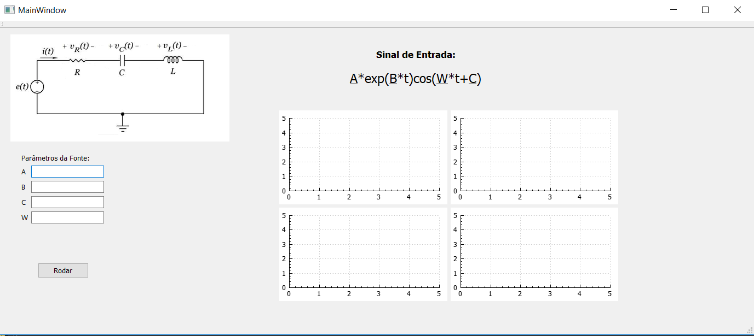

Figura 1.Esboço do Programa